|  |  |  |  |  |  |
| --- | --- | --- | --- | --- | --- |
| Date | Sept 23, 2022 | | | Tester Name | Alyssa Johnson |
| Environment | Penfax - Test | | | Login used |  |
| Operating System | Select OS | Version: | Update: | | |
| Software Used | Select Software | Version: | Update: | | |
| Select Software | Version: | Update: | | |
| Release version | 22.3.0 | | | | |
| Title | E23.06 | | | | |
| Test Type | Regression | | | | |
| Test Scenario | Process VPB monthly payment production | | | | |
|  |  | | | | |
| Expected Results | Process VPB payroll.   * Ensure that the PIT runs successfully and any warnings/errors are accurate * Check a few members that all payments are processed successfully and taxed correctly. * Check a non-resident (if applicable) to confirm taxes * Verify that payments are separated & nothing in payroll shows as a vendor payment * Verify that the Cheque extract & EFT extract are generated | | | | |
| Pass/Fail | Pass | | | JIRA# | N/A |

If payroll has already been run for a month, we can change the current payroll month end

* Go to Plan Rules/Plan Parameters & set the plan to PEPP in the top left.
* Change the current payroll month end to the last day of the current month.
* Changed from October 31, 2022 to Sept 30, 2022

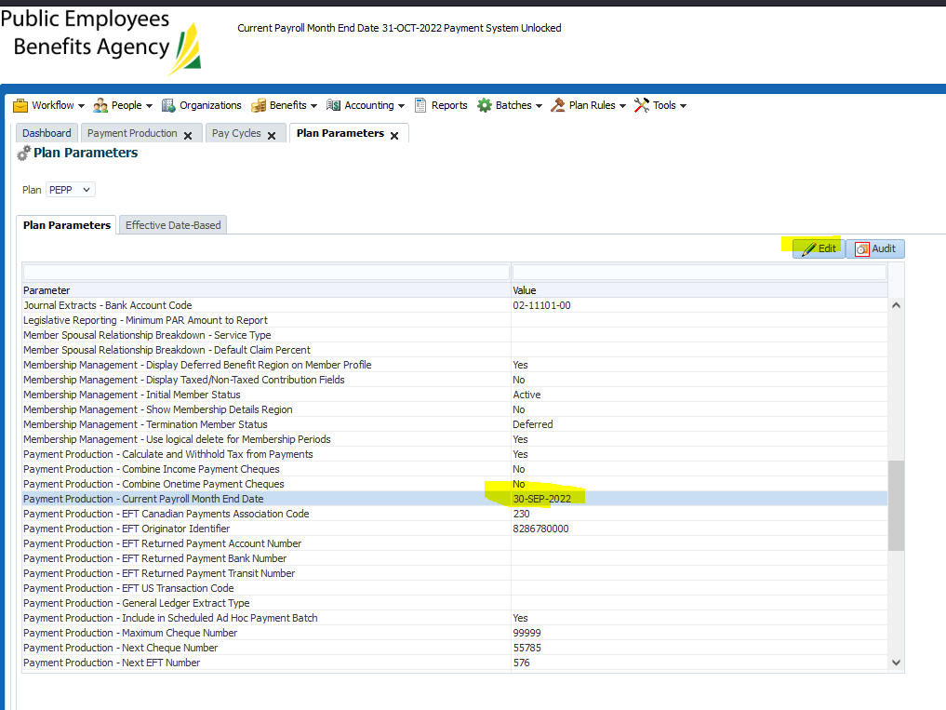

Ran payroll “test” to confirm/validate any warnings (as per business procedure):

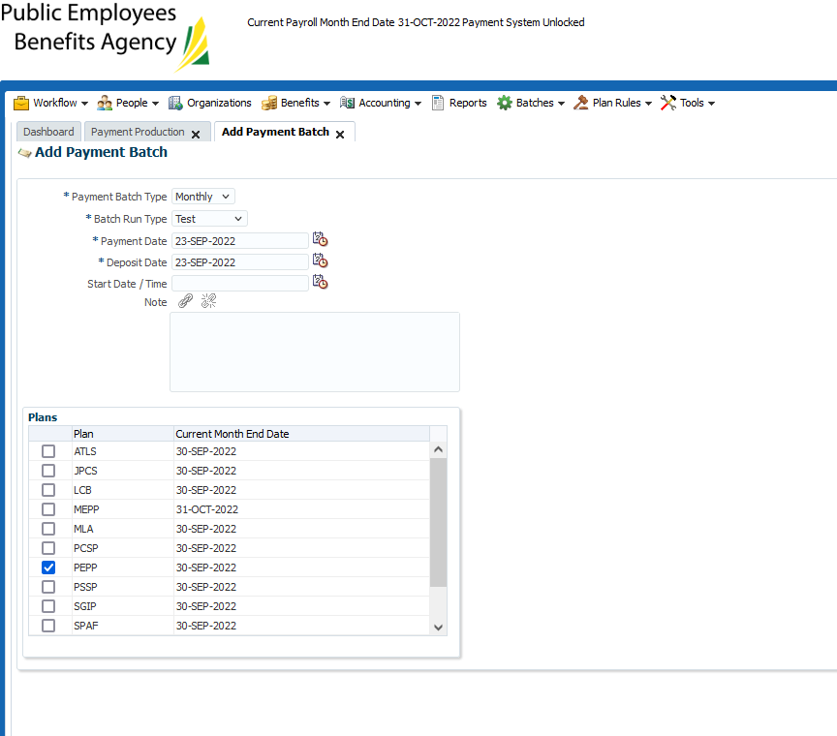

Once it’s completed, it will show the status as completed successfully.

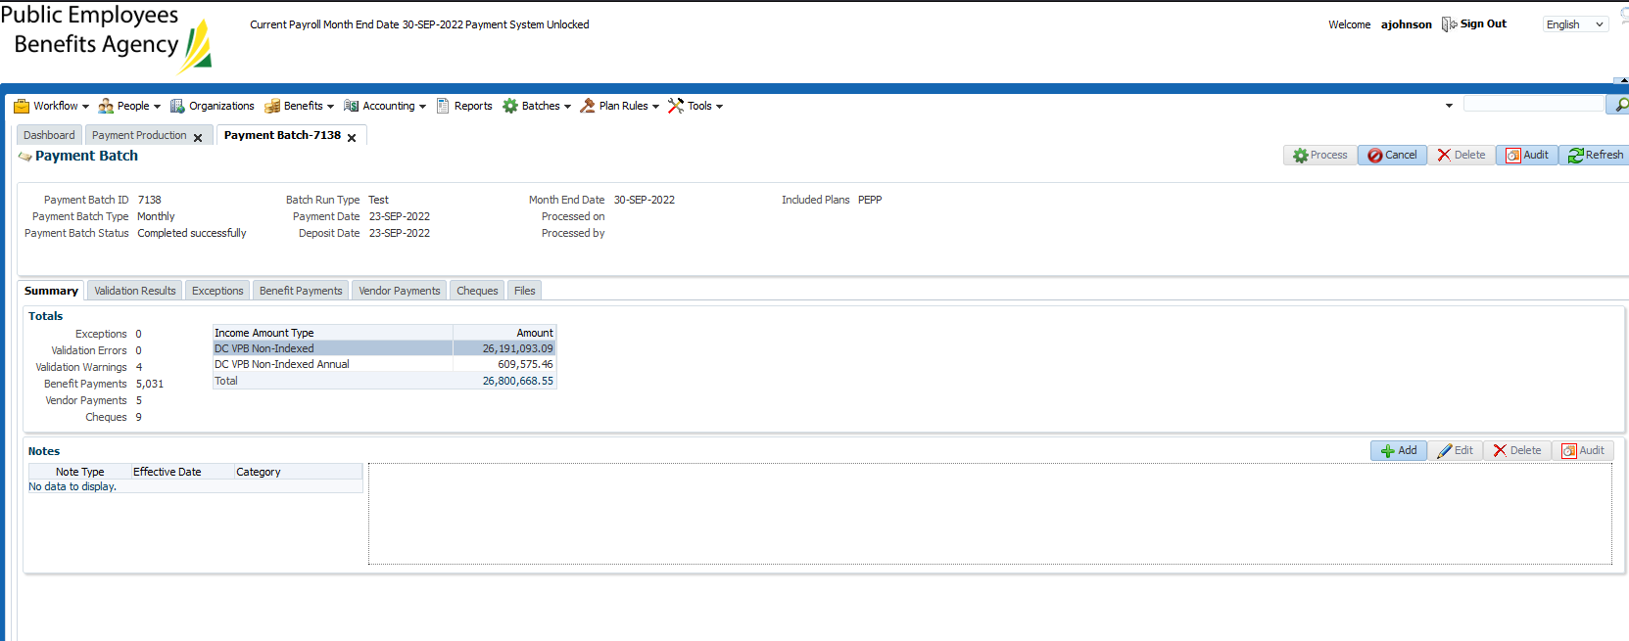

Check the validation results:

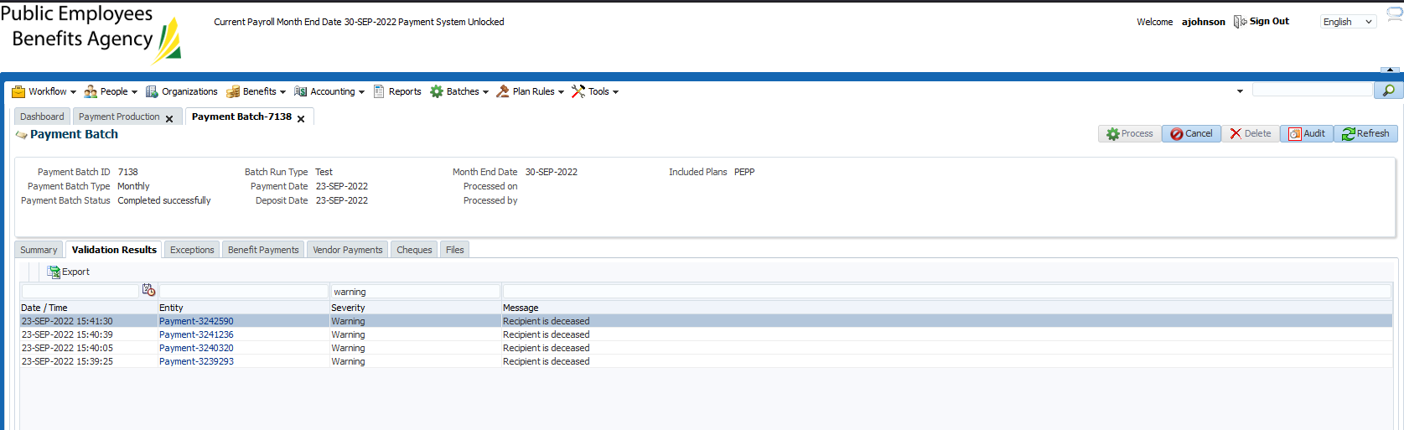

Investigate anything other than recipient deceased.

Then go to the benefit payments tab, and click export.

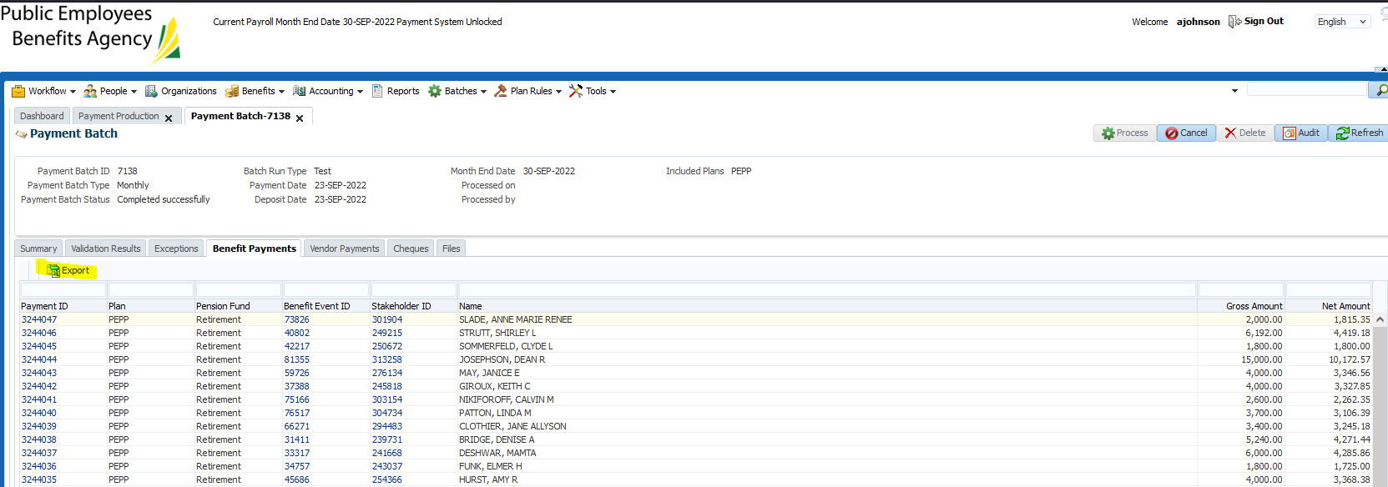

We need to confirm that none of the net amount entries are for 0.00 before proceeding

Open the document in excel and choose sort and filter on the net amount column, smallest to largest to confirm there are no $0.00 entries.

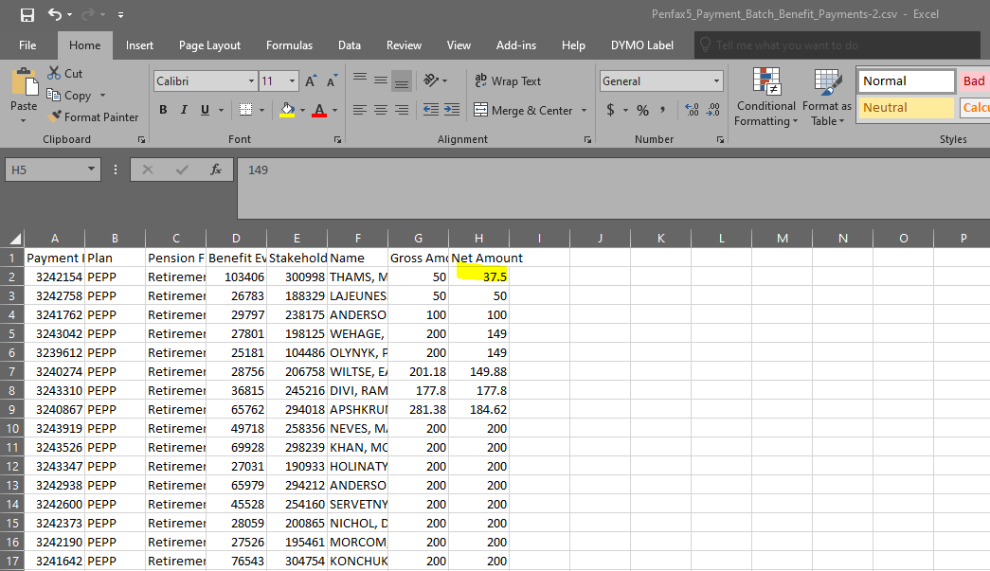

Now complete the payment batch in production:

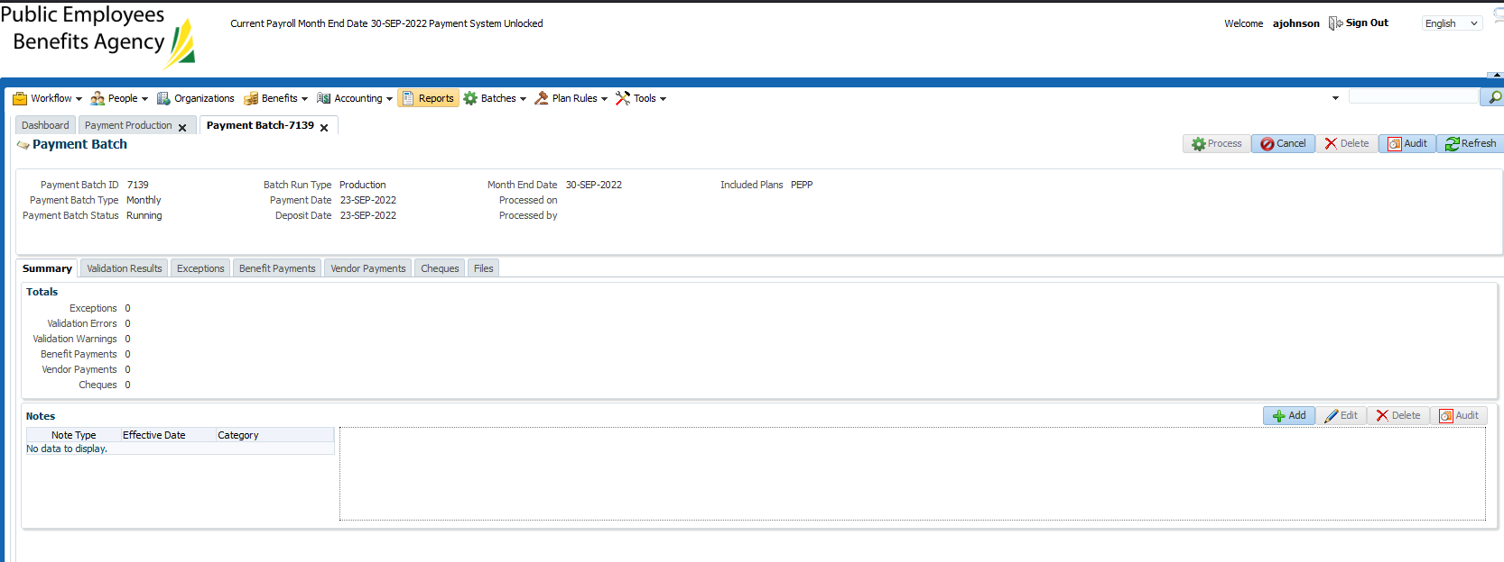

Wait for it to finish running:… didn’t press process/finish running same day, so had to re-run on Sept 26th.

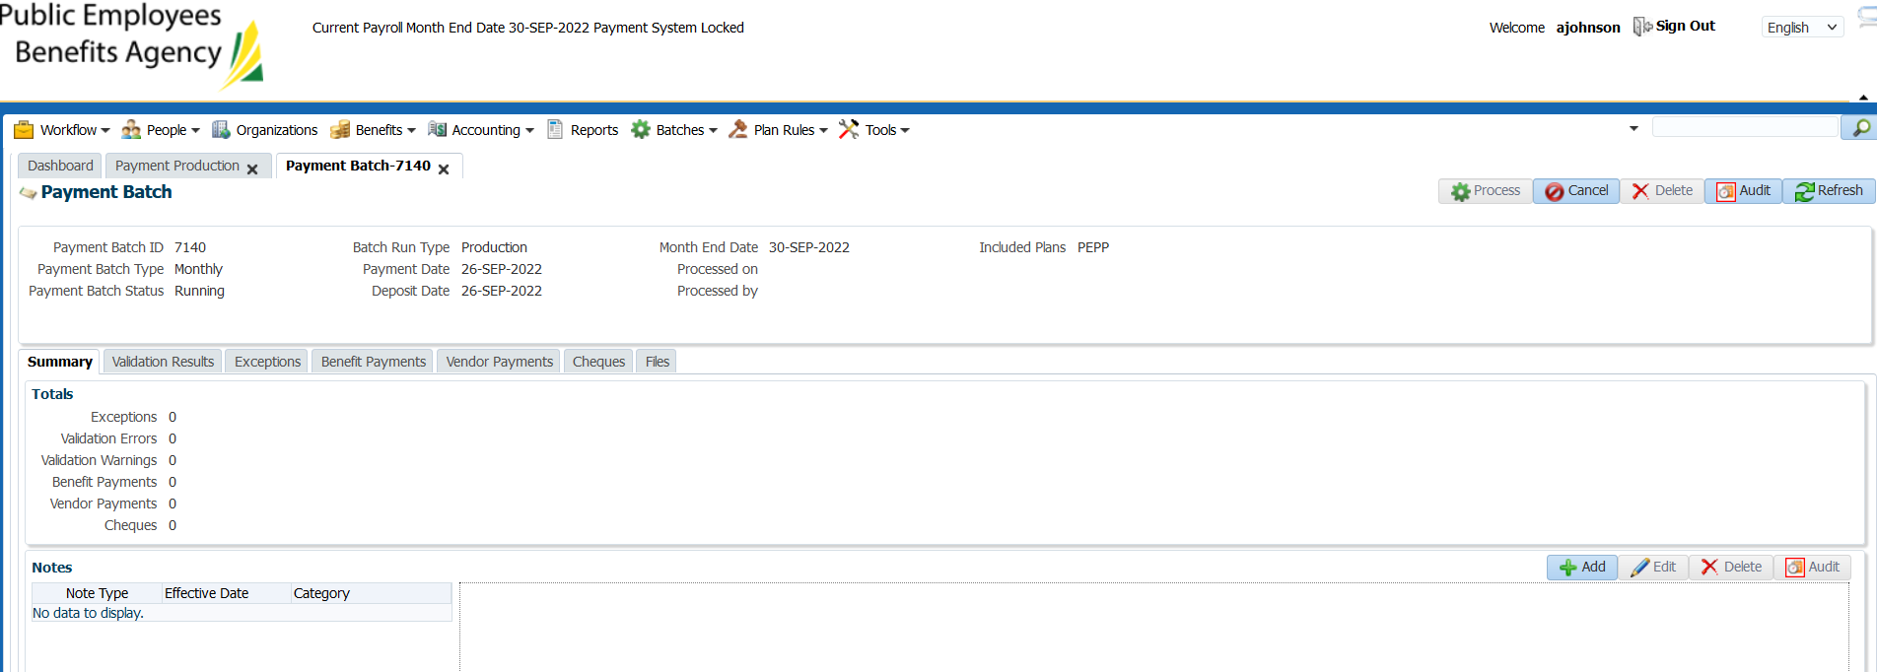

Re-ran and once it said “completed successfully” the process button was still greyed out.

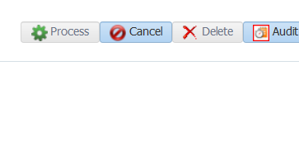

Spoke to Jordan and he suggested cancelling it & re-running it & determine if it continues to be grey. Potential in a previous release there was a refresh issue with buttons being greyed out.

Running again:

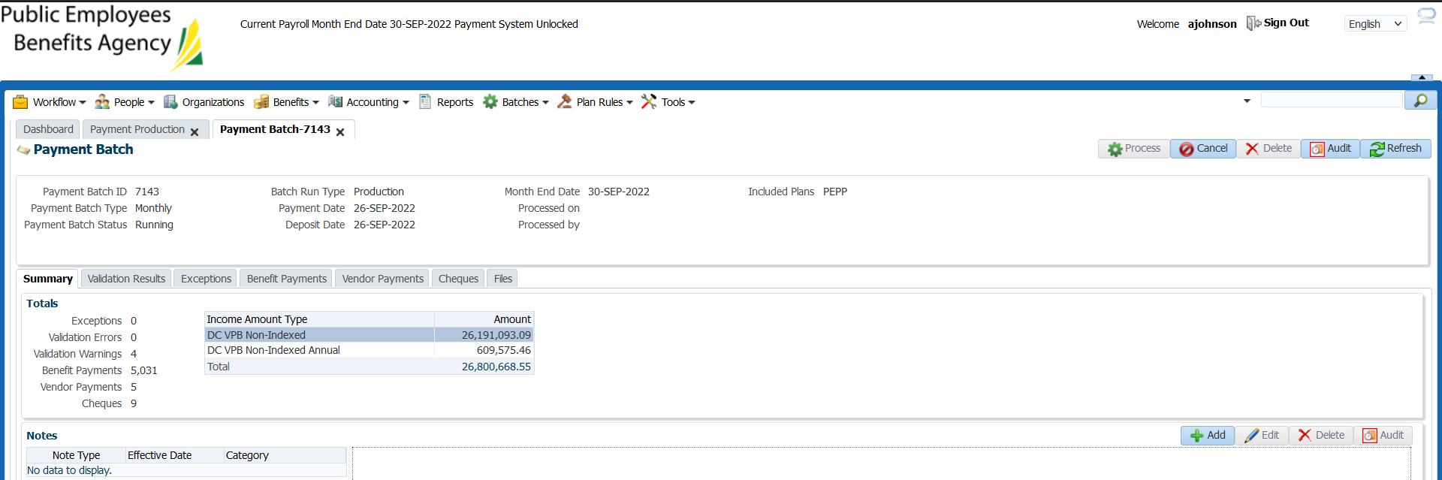

Completed successfully, process button is NOT grey

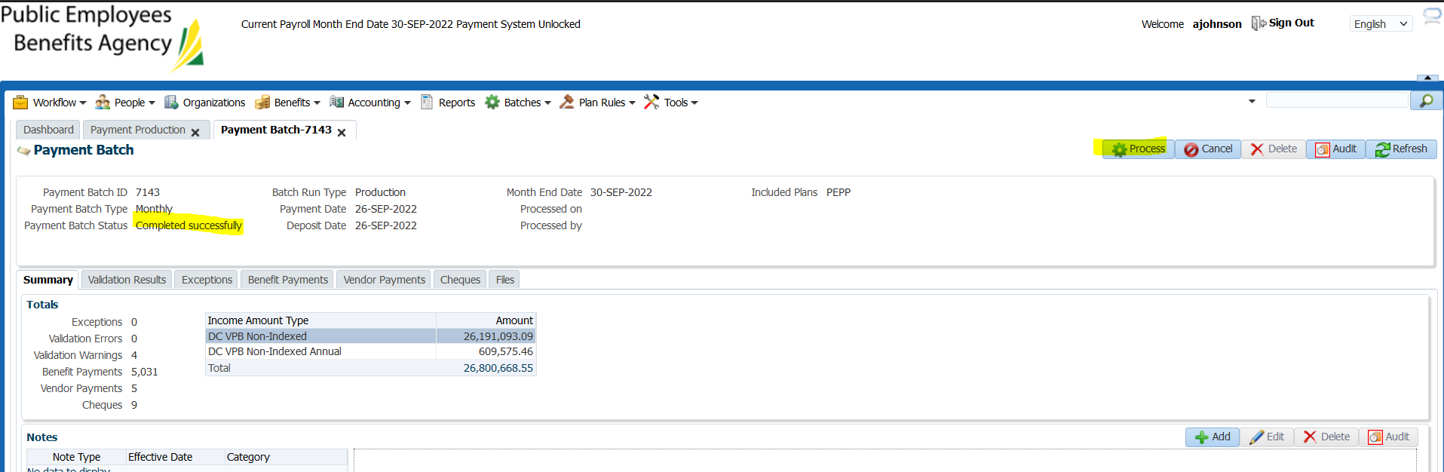

Switching tabs again to see if I can replicate the issue, clicking back to payment production screen:

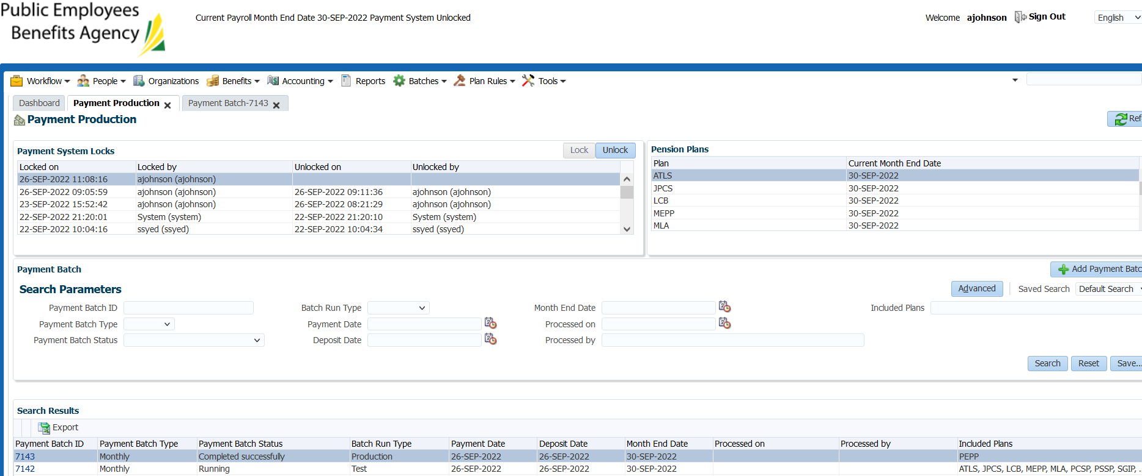

Button is not greyed, clicked “process”

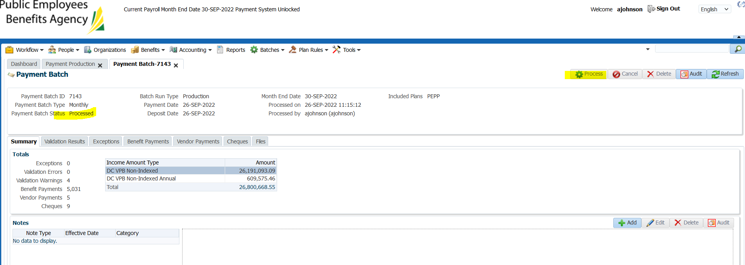

Continue to verify payroll results, checking a few members:

SID 245818

Why did it double the amount?? The other batch processed today was cancelled??

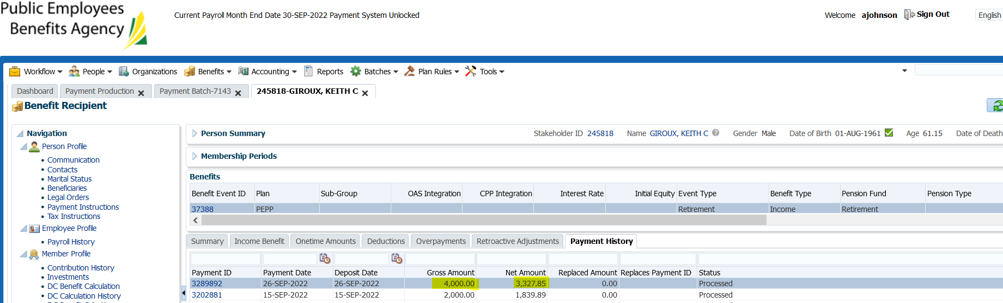

-confirm investments/unit values tomorrow& see how much is w/d from mbr account

SID 255362

-why did it double the amount??

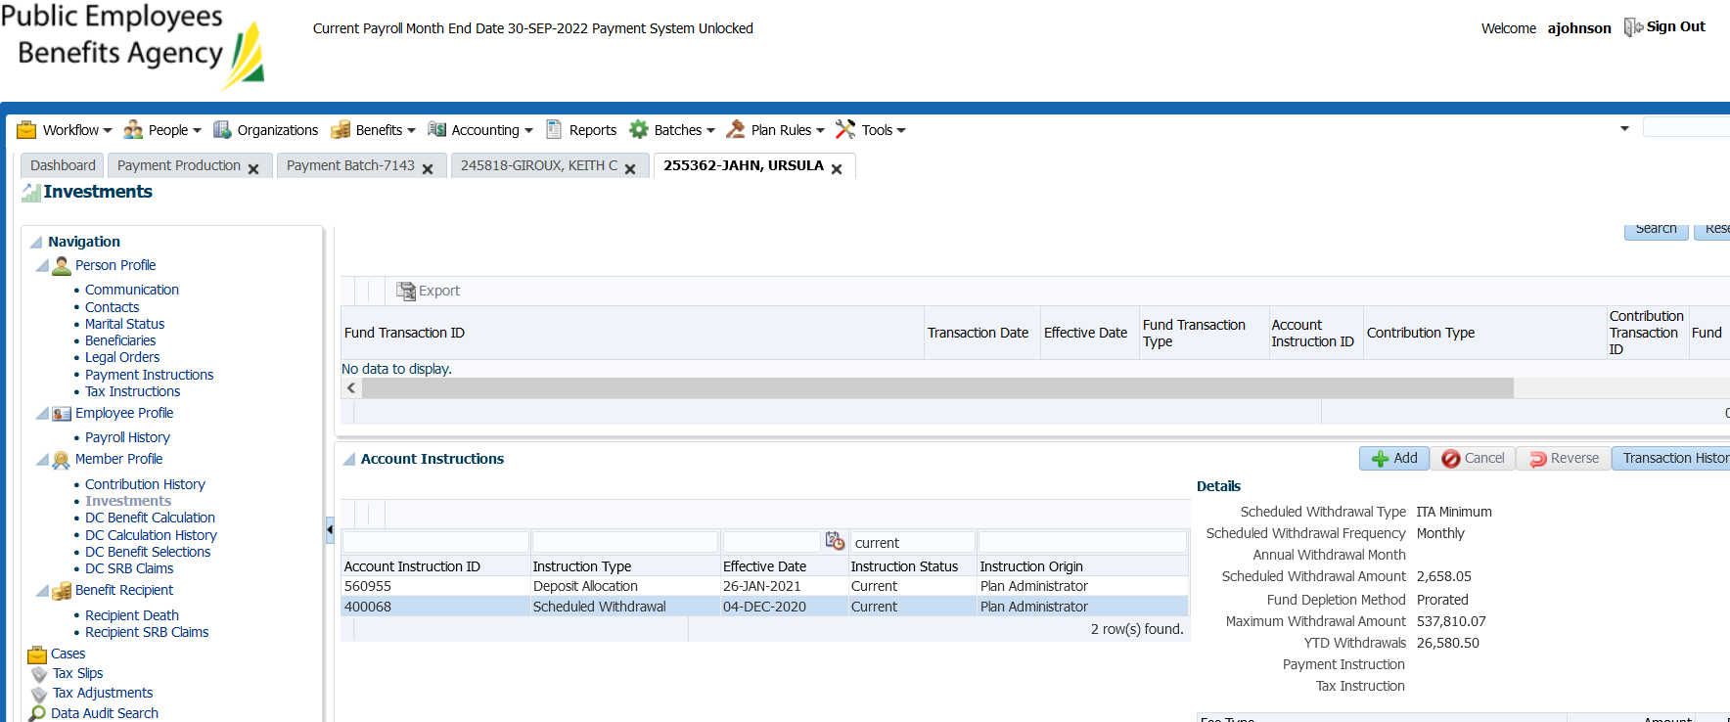

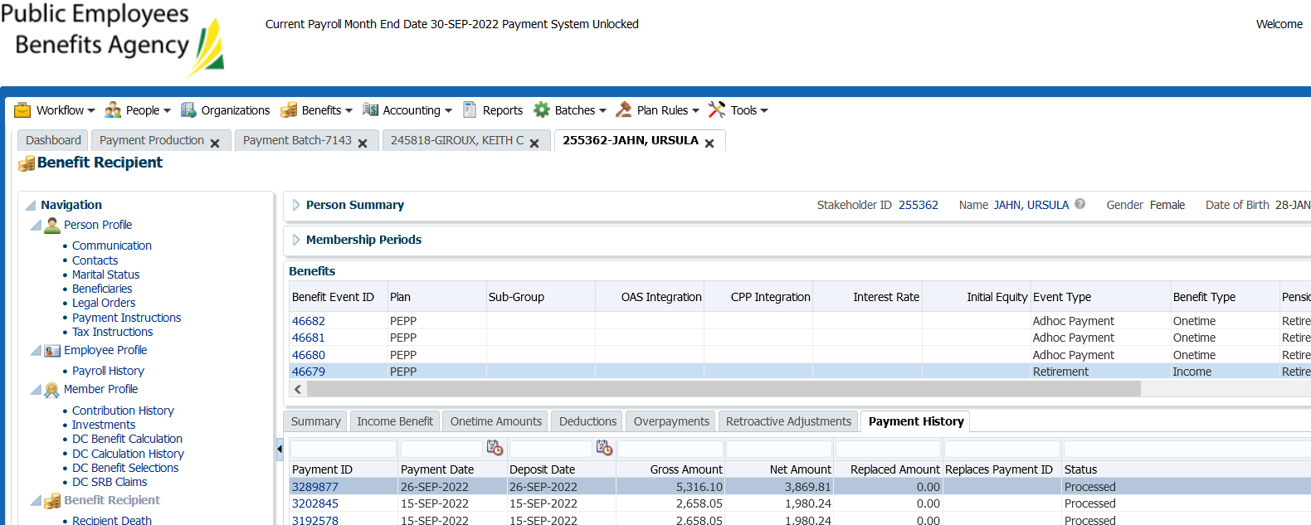

Confirm amounts w/d from members account tomorrow

Could it have to do with the cancelled batch?